Category 6A Unshielded Keystone Jack

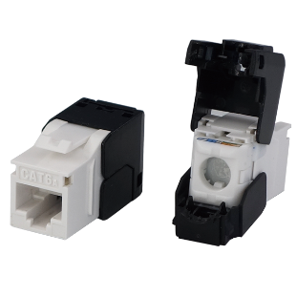

Category 6A unshielded keystone jack supports the 10/100/1G BASE-T Ethernet, as well as advanced 10G BASE-T Ethernet, meets and exceeds ANSI/TIA-568.2-D and ISO/IEC 11801 2nd edition standards. By special designed housing and installation the jacks on a staggered 24-port 1U patch panel, it minimizes additional AXT from neighboring connectors, and provide transmission performance beyond 500MHz and Alien crosstalk requirements.

Features

Contacts are phosphor bronze plated with 50 micro inches hard gold

Dual T568A &amp; T568B wiring

Polycarbonate 94V0 rated

Itertek ETL / Force EC Cat.6A VERIFIED

4PPoE compliant in accordance with IEEE802.bt Type 4

Ordering Information

|  |  |
| --- | --- |
| PART | Description |
| 1A68TP0A0-XX | RJ45, 8-Conductor Cat.6A , Tool-free, Unshielded, 180 degree, H.D. version |
| 1A68IP0A0-XX | RJ45, 8-Conductor Cat.6A , 110 IDC, Unshielded, 180 degree, H.D. version |
| 0A68IP0A0-XX | RJ45, 8-Conductor Cat.6A , KRONE/110 IDC, Unshielded, 180 degree, H.D. version |
| 6A68TP0A0-XX | RJ45, 8-Conductor Cat.6A , Tool-free, Unshielded, 180 degree. |
| 7B68TP0A0-XX | RJ45, 8-Conductor Cat.6A , Tool-free, Unshielded, 180 degree, H.D. version |
| 1C68TP0A1-XX | RJ45, 8-Conductor Cat.6A , Tool-free, Unshielded, 180 degree, H.D. version, no cable tie required |
| 1T68TP0A0-XX | RJ45, 8-Conductor Cat.6A , Tool-free, Unshielded, 90 degree, H.D. version, L=35.0mm |

“XX” = color choices – ivory (IV), white (WH), gray (GY), black (BK), red (RD),orange (OR), blue (BL), green (GN), yellow (YL)